Computer Vision project: 3D shape reconstructor from photos.
The objective of my project was to create a program which, given as an input a set of photo of an object, it will give as an output a pointcloud which represent the shape of that object.
To do that I initially thought to recognize feature points, and than triangulate the position of those points recognized in different photos, but with my test object, which was a mouse, the feature point were not really recognized always in the same place making this technique not effective.
So my strategy switch to the following technique:
If from a photo you recognize the contours of the object you want to reconstruct you are sure that the object (in the 3d space) is in the cone which is formed connecting the point from which the photo has been taken to the points of the contour of the object. If then you do the intersection (if you make an “and” of all the zones inside the cones) of all those cones you find the shape of the object.
For this to work the project has been divided in 3 steps:
-Recognition of from where the photo has been taken.
-Recognition of the contour of the object.
-Putting everything together to get the object.

Disclaimer
This project uses some parameters which are tuned for a 4000x3000 photo and for the camera of my phone (which is the one I used to take the pictures I later used in the 3d reconstruction) and is not said it will work correctly with any dimension of the photo or with different cameras.

1) Recognition of from where the photo has been taken
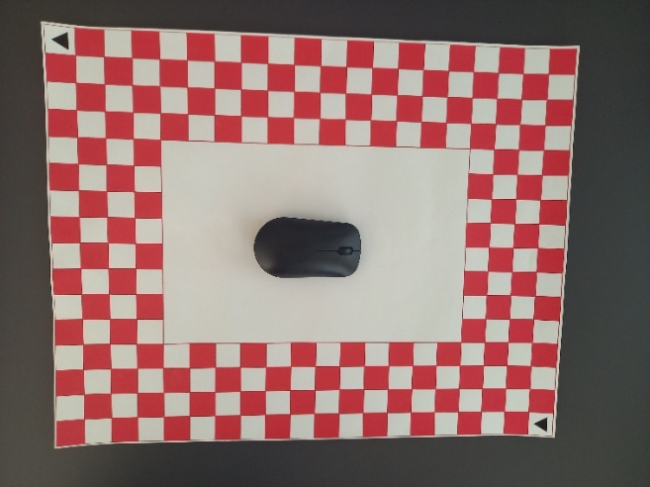
To do this point the idea was to use the same technique used in camera calibration.
To do that we should have a set of points recognized in every photo.
In order to obtain that I created a personalized chessboard with edges all on the sides, which I could recognize maintaining my object at the centre of the photo.

(The chessboard is red and white because there is a part of the program where I take only the red channel in order to find where is the object)
In order to recognize which edge is which I had to do my own functions, since it was a particular problem.
Now it will follow an explanation of the method I used.
All what I will explain in this chapter is contained in the files allinonecalibratio and b_bin_corener.
In the all_in_one_calibration file is repeatedly called the method to find the corner in the images, is called the cameraCalibration function and all useful information are written in json files.
In the p_b_corner file there is the method to find the corners, this method returns the coordinates of the found corners in the images and the real coordinates this points would have.
This was the hardest part of the project and I have done a bit of a “do it yourself” solution, which may be not particularly robust.
The function called is the function get_points.
The first thing this function does is finding the square of the chessboard, in order to do that it calls the obtain_square function.
What this function does is first finding the square of the chessboard, to do that it finds edges with the sobel function, it binarize the image found in such way (with a low threshold), then it uses the findcountors function in order to find the contours in the image, then it discard all the contours that doesn’t have exactly 4 edges and that don’t respect some specific area contrain. Once it has found the square it orders them.
To do that first it finds the triangles at the corner of the images, and starting from there it starts a procedure to find every square corresponding to a given square on the chessboard. (More of that in the appendix 1)
The triangles are found in the same way the squares are found but the initial image is not the one obtain finding the edges but it is the starting image, binarized and masked far away from the chessboard in order to do not recognize unwanted triangles.
Later it finds all the corners, and using the fact that it knows which square is which it understands which corner is which searching from corners that are near the corners of the near squares.
If it finds a corner it appends to 2 different list both the position on the image of the corner and the real position that that corner should have.

2) Recognition of the contour of the object.
All the parts explained in this chapter are contained in the prova_elimina_rosso2 and protipo_p2 files.
The prototipo_p2 just call the obtain_border function for every image and write the information on a json file.
The obtain border find the border of the object with the sobel function, but with this method it finds also all the border of the chessboard and of the part of the image outside the chessboard, so to keep only the object’s border it mask the image outside the chessboard and find the object looking only at the red channel, in such a way the chessboard almost disappear, and then it binarizes the image, such image is then dilated, to deal with possible errors.
Is then taken the and of these 2 images (the ones with the corner and the one with the object) and in such a way it finds the border of the object.
I used the sobel function and not just the binarized part with disappearing red because in the binarization some part of the object might get lost due to reflection of light on the object.

3) Putting everything together to get the object.
Explanation of the method i used.
The last part is contained in the files get_lines, p3_2single_level and prototipo_p3.
In this part the space is divided in horizontal planes, for every plane, for every photo it creates an image which is zero everywhere and 255 in the parts inside the cone created in the way explained before (on this image is done some work in order to obtain the intersection between the ideal cone and the plane it is taking in consideration, (more on appendix 2)) it sums those images obtained with every photo, it smooths it, it divides the founded value for the number of images, and it takes all the points with value greater than 240 (the program allows a bit of error). This process is repeated for every plane and all the points on the border of those resulting images are appended on a list to then be shown.

Result
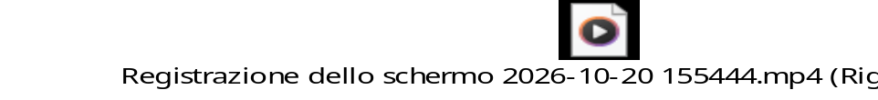

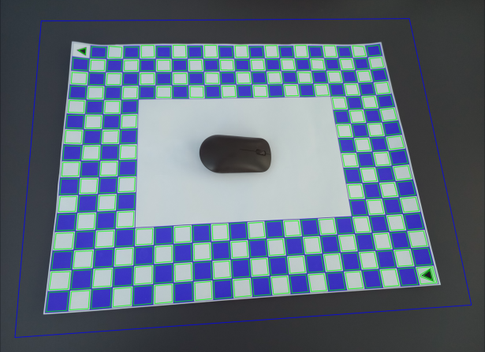
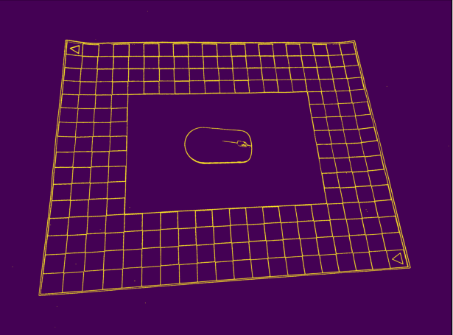
Appendix 1
Squares founded drawn on the initial image,
The image is blue instead of red because is the colour representation on a grey image.
Outside the big square the image is masked for some part of the project

After having found the squares
Binarized image of the edges.
The procedure to find every square in the chessboard is the following:
(Instead of working with squares it works with the average points of the corners of the squares)
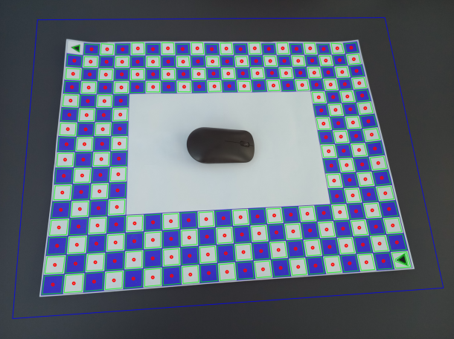
Image of all points representing the position of the squares, of the recognized squares.
Starting from the position of the triangles it find the next squares finding the closest point to the one we are right now which respect some constrain for the direction it has to be and how far away it can be (the direction is calculated at every iteration) + this procedure deals with possible errors inserting “fake squares” where it doesn’t find it and has a reason to believe there should be one there. (fake squares are possible to recognize in later stage of the program because all of their edges are [0,0], only their position is a real coordinate.)
Then it uses the information of the positions of the squares to find the correct edges for the corresponding real world coordinates.
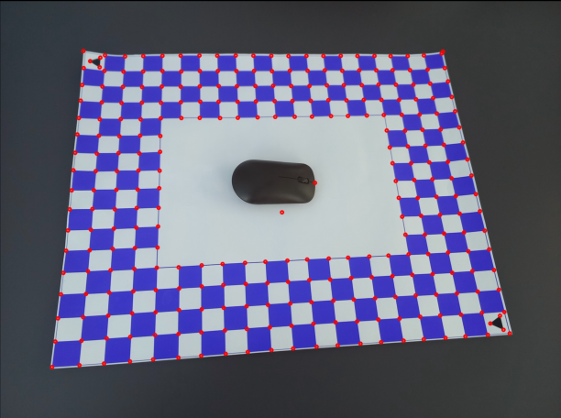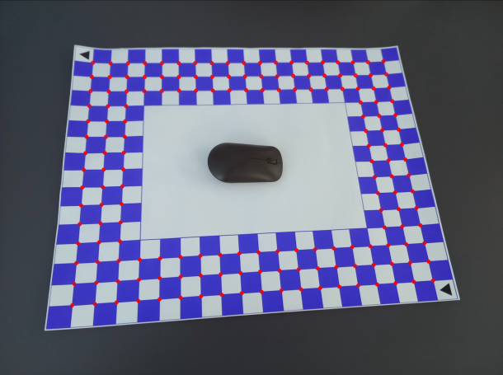
Image of all the points where it knows the corresponding real world coordinates.
Later used for the camera calibration and thus to find the position and angulation of the camera
Image of all the points it can find.

Appendix 2
To find this image the program finds a set of points which represent to contour of the image, and for every one of those points it find the corresponding point on the plane, which is the intersection between the line passing form the point from which the photo has been taken, and it has the correct angulation founded with the angulation it should have considering the position on the image and rotate this angulation with the rotation matrix; and the plane it is taking in consideration (this phrase is the end of which is the intersection…).

